
Business Question and Visualization Report

Date | Aug 24, 2026
Team ID | Individual
Project Name | India's Agricultural Crop Production Analysis
Maximum Marks | 5 Marks

Visualization development refers to the process of creating graphical representations of data to facilitate understanding, analysis, and decision-making. The goal is to transform complex datasets into visual formats that are easy to interpret, enabling users to gain insights and make informed decisions. Visualization development involves selecting appropriate visual elements, designing layouts, and using interactive features to enhance the user experience. This process is commonly associated with data visualization tools and platforms, and it plays a crucial role in business intelligence, analytics, and reporting
Business Questions and Visualisation
The process involves defining specific business questions to guide the creation of meaningful and actionable visualizations in Tableau. Well-framed questions help in identifying key metrics, selecting relevant data, and building visualisation that provide insights.
Sample
- How does the total cultivated area vary among different crops?
  - Visualization: Comparison of Cultivated Area by Crop
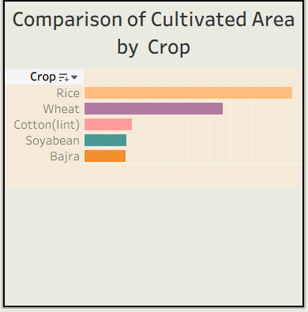
- Which states are the leading contributors to agricultural production?
  - Visualization: Leading States by Agricultural Production

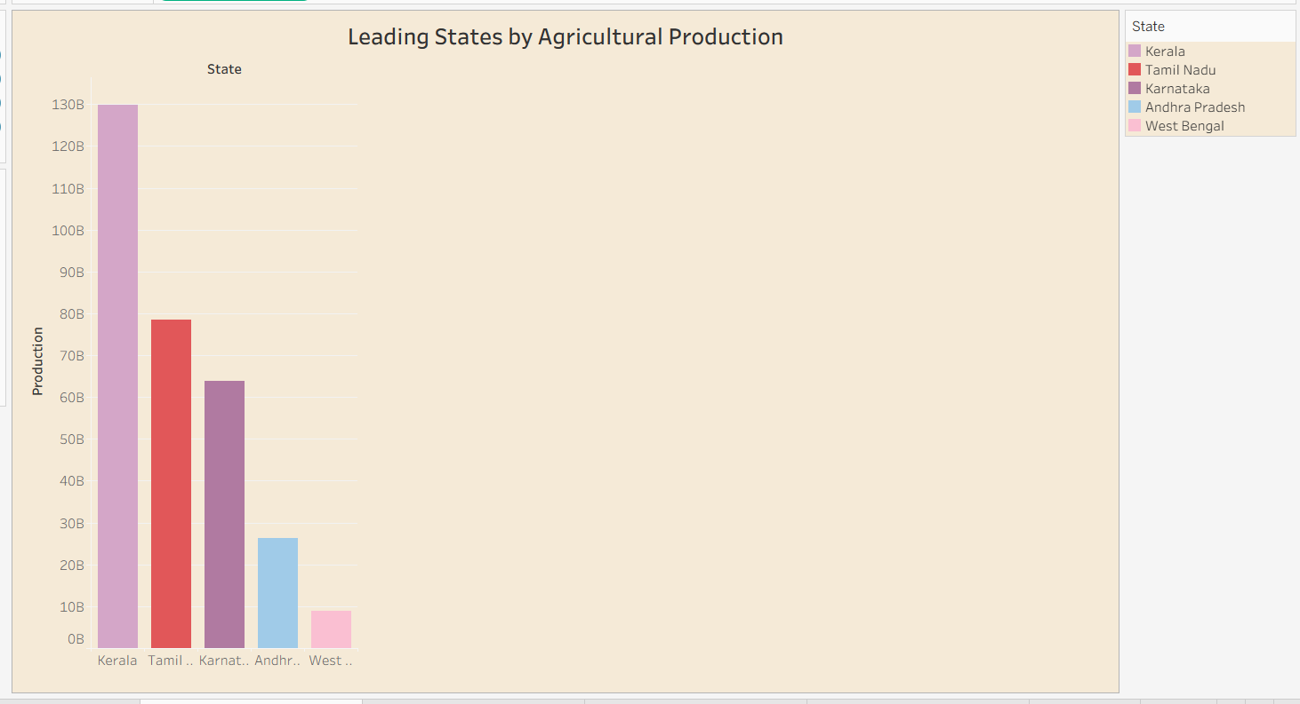

- How has agricultural yield changed in India from 1997 to 2021?
  - Visualization: Trend Of Agricultural Yield.

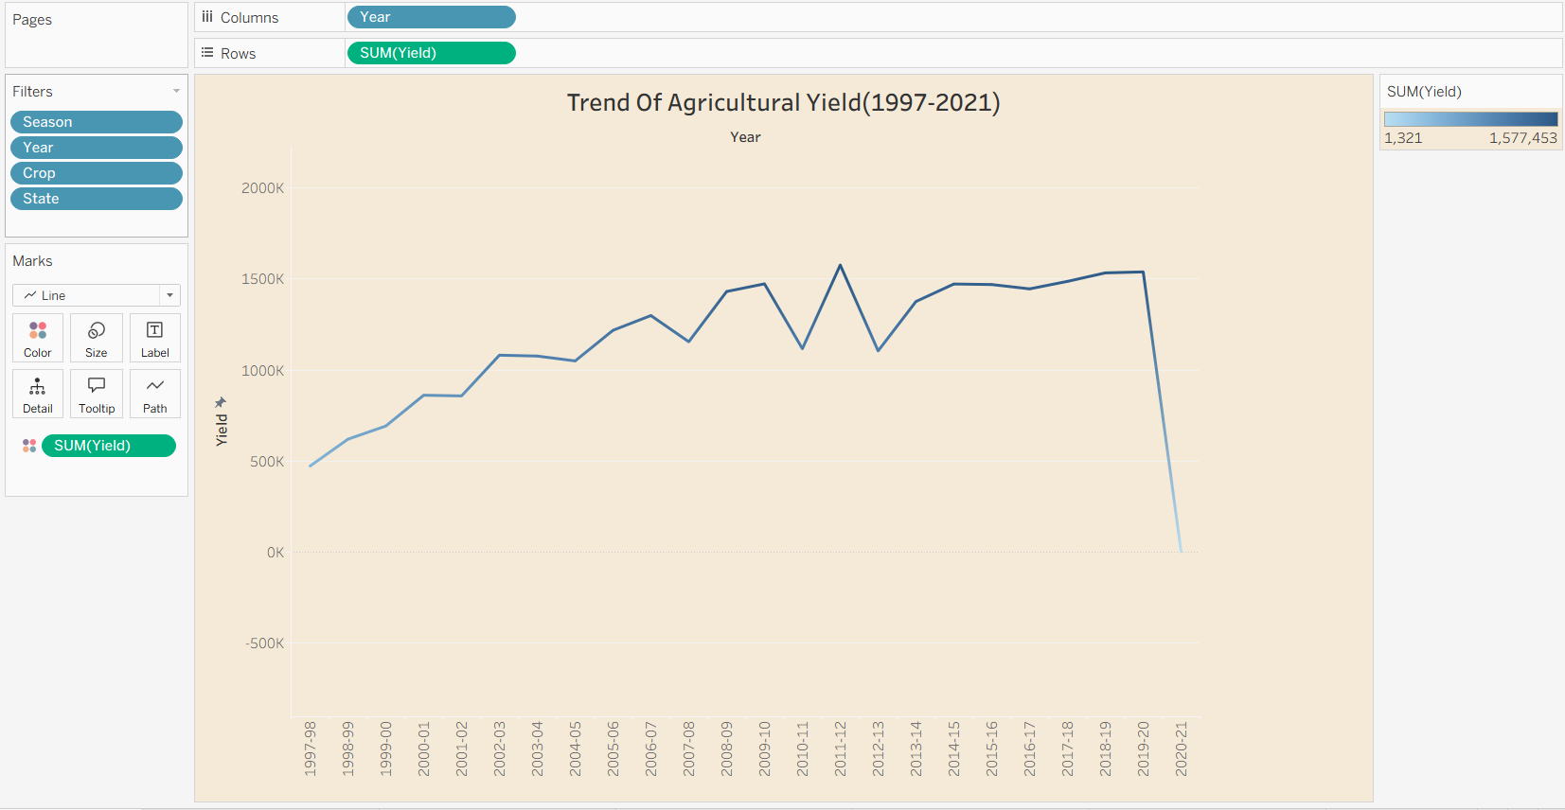

- How does cultivated area compare among different states?

  - Visualization: State Wise Cultivated Area Comparison
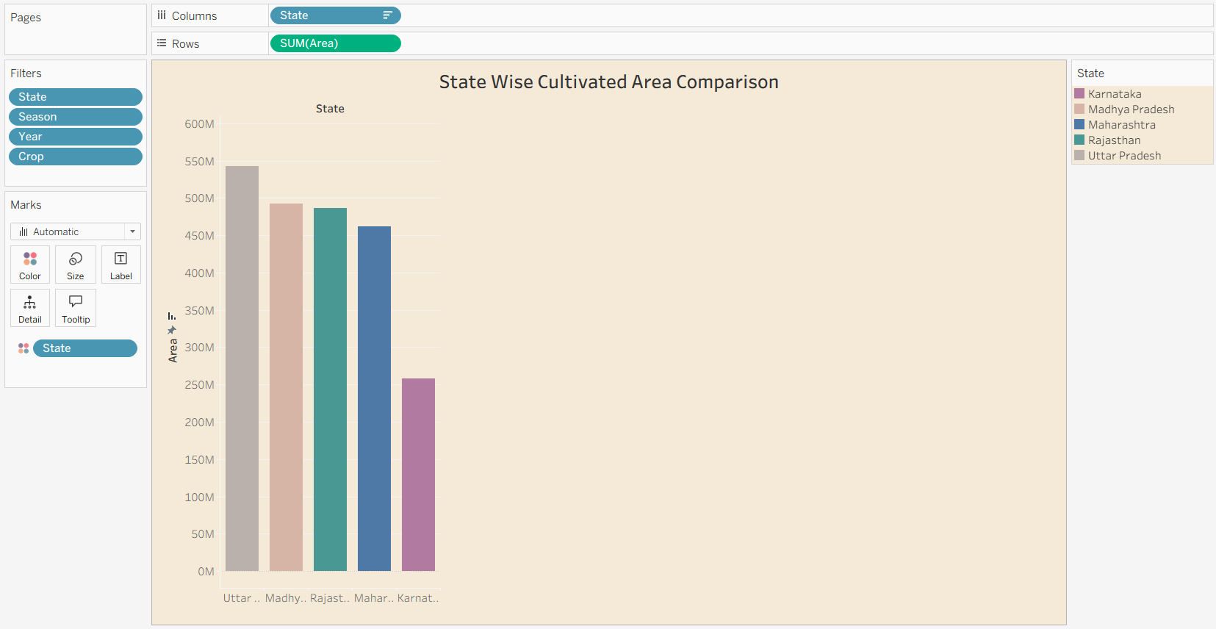

- How has total agricultural production changed from 1997 to 2021?
  - Visualization: Year Wise Total Agricultural Production
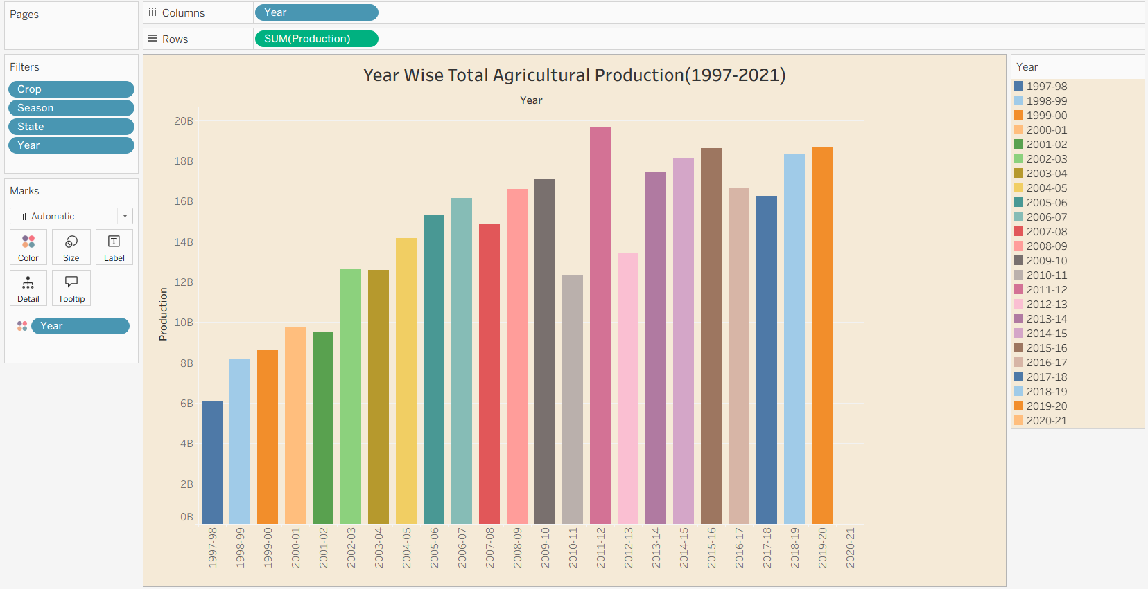

- What share of agricultural production is associated with different seasons?
  - Visualization: Season wise Agricultural Production Share
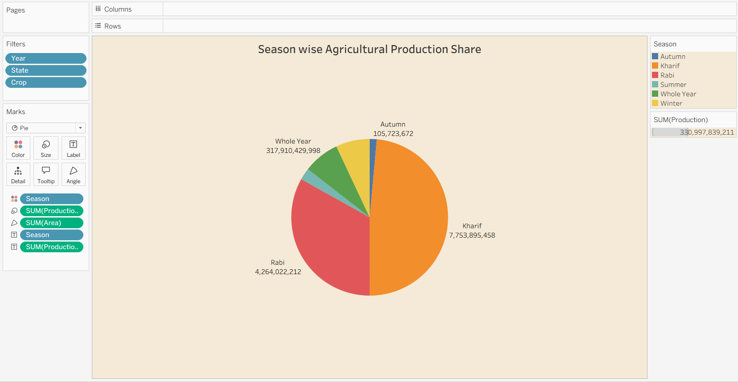

- How is agricultural production distributed geographically across different states in India?
  - Visualization: State Wise Agricultural Production Distribution (India)
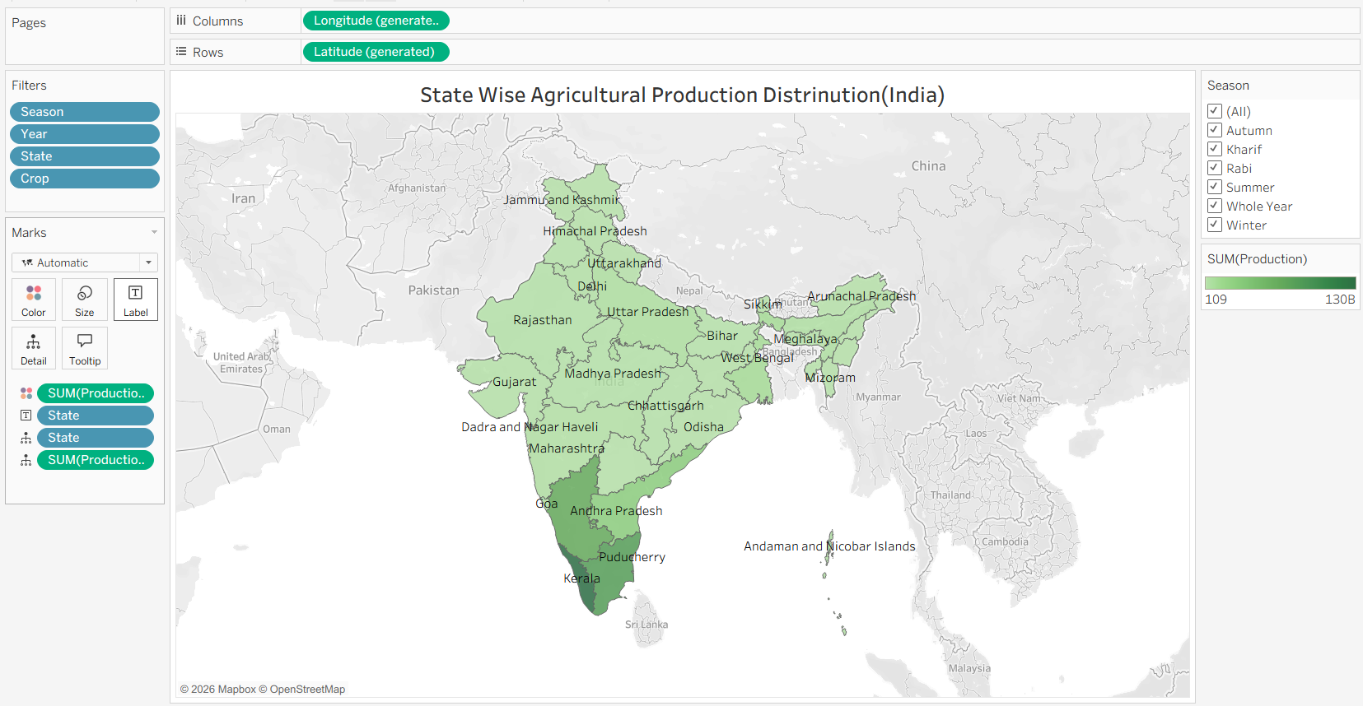

- How is agricultural production distributed by unit type?
  - Visualization: Production Distribution by Unit Type
